.
Boris
Albert
Spencer
Lewis
Carlos
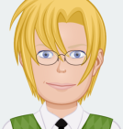
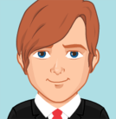




Dieter
Ernest
Frank
Gareth
Hans

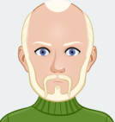




Victor
Roderick
Oscar
Parminder
Walter






Maurice
Karl
Janson
Ibrahim
Nathan







Group A: Has he got...

...balding ...white ...blue
...short hair? ...brown ...brown eyes?
...long ...red hair? ...black

...fair
...straight ...black
...curly hair? ...a beard? What does
...wavy ...a moustache? he look like?

big nose? ...glasses? He has got . . . . . . . . . . . . . . . . .
...a . . . . . . . . . . . . . . . . . . . . . . . . . . .
small mouth? etc . . . . . . . . . . . . . . . . . . . . . . . . . . .
. . . . . . . . . . . . . . . . . . . . . . . . . . .
Group B: Yes, he has / No, he hasn’t
.
Alba
Barbara
Charlotte
Ruta
Francine
Guadalupe
Helen
Isabela
Jill
Katherine
Lynne
Monica
Jurgita
Nora
Ursula
Valeria
Zahra
Brigitte
Susan
Manisha


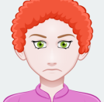











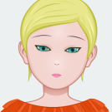
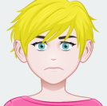


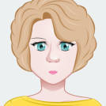






Group A: Has she got...

...balding ...white ...blue
...short hair? ...brown ...brown eyes?
...long ...red hair? ...black
...fair
...straight ...black
...curly hair? ...a beard? What does
...wavy ...a moustache? she look like?

big nose? ...glasses? She has got . . . . . . . . . . . . . . . .
...a . . . . . . . . . . . . . . . . . . . . . . . . . . .
small mouth? etc . . . . . . . . . . . . . . . . . . . . . . . . . . .
. . . . . . . . . . . . . . . . . . . . . . . . . . .
Group B: Yes, she has / No, she hasn’t

